7.1.1. Measures initiated by the Institution for the promotion of gender equityduring the year.

Response:The courses offered by the College in Social Science disciplines like Political Science, Sociology etc have a component of gender studies, which are taught by teachers who have specializations in their particular disciplines.
The Margherita College is dedicated towards creating a gender inclusive campus through various programmes, organized by the Women Studies and Development Cell (WSDC), Sexual Harassment Prevention and Empowerment Cell and other College societies. These programmes address self-defence, reproductive and mental health issues of women and the significant roles they can play in different spheres of society.
Over the years, the proportion of women in the teaching faculty has improved to almost 50 percent. Moreover, the specific programmes for the promotion of gender equity by the institution during the year is mentioned below:
- Self Defence Training for Girls was conducted at college premises from 1.12.2020 to 10.12.2020 by State Level Advisory committee for students and Youth Welfare, Govt. of Assam. Studentparticipants= 120 Trainers were Mr. Anjan Chetia DU, Mr. Abhijit Saikia, Mariani.
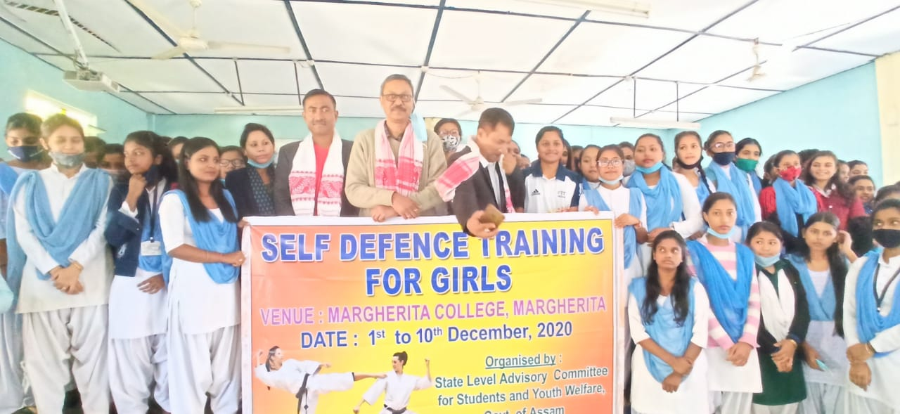

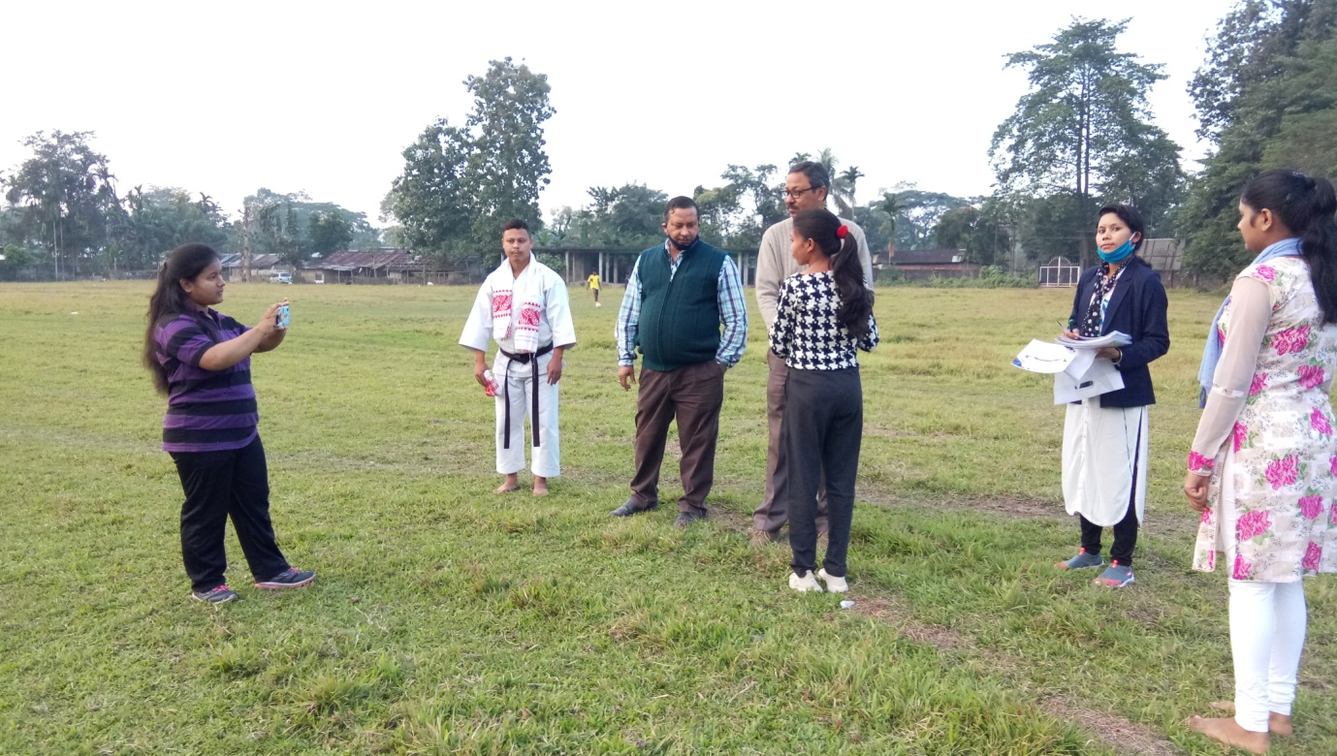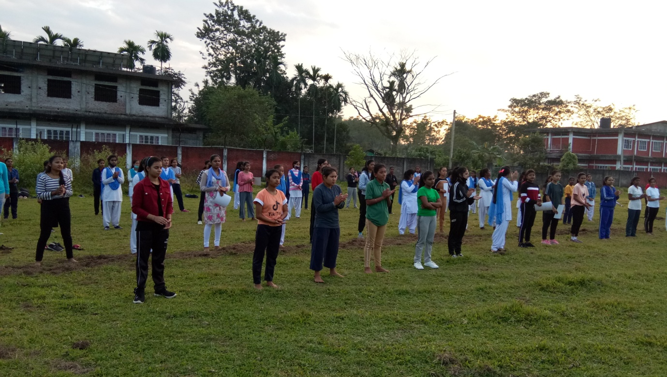

- International Women Day was celebrated at the initiation of WSDC on 8.3.2021. At the occasion a lecture was delivered by Dr. Debajit Singha, Principal, Dr. Deba Bora, Vice Principal, Mrs. Chitra Borgohain & Dr. Kasturi Nath. All of them have delivered lectures on the theme, International Women day 2021, “Choose to Challenge”. The wall magazine of the Cell, Ananya, 14th volume was unfurled.
- A Lecture Programme on Empowerment of Girl Child (Facebook Page) was conducted on 17.07.2020.
